**MCQs ON THREADING AND MULTI-THREADING**

1. What is true about threads? Ans - d
2. Threads consumes CPU in best possible manner.
3. Threads enables multi processing.
4. Multi threading reduces idle time of CPU
5. All
6. Which of these is not a Thread state? Ans - c
7. New
8. Runnable
9. Sleep
10. Terminated
11. How can Thread go from waiting to runnable state? Ans - d
12. notify/notifyAll
13. When sleep time is up
14. Using resume() method when thread was suspended
15. All
16. How can we create Thread? Ans - d
17. By Extending Thread class
18. Implementing Runnable interface
19. Only a
20. Both a and b
21. What is difference between starting thread with run() and start() method?
22. There is no difference
23. When you call start() method, main thread internally calls run() method to start newly created Thread
24. run() calls start() method internally
25. Both b and c Ans – b
26. Which one of the following constructor is NOT a valid constructor of thread class? Ans - c
27. Thread()
28. Thread(String name)
29. Thread(Runnable target, Object obj)
30. Thread(Runnable target, String name)
31. Thread(ThreadGroup group, String name)
32. Java is a multi-threaded programming language means that ? Ans - b
33. Multi-threaded applications can be developed in Java
34. Each application of Java has multiple threads
35. JRE is executed by the O/S as a thread
36. All
37. (i) A Thread Object Ans - d

(ii) A Runnable Object

(iii) Both a Thread and a Runnable Object

1. Only (i)
2. (i) and (ii)
3. (i) or (ii)
4. (i) or (iii)
5. What is the default priority of a thread?
6. 0
7. 1
8. 5
9. 10
10. On a sleeping thread, isAlive() method is invoked, its output will be ?
11. True Ans - a
12. False
13. InterruptedException will be thrown by the thread
14. Still in sleep mode
15. What is the default priority of a newly created thread? Ans - b
    1. MIN_PRIORITY
    2. NORM_PRIORITY
    3. MAX_PRIORITY
    4. None of the above
16. What is dead thread in Java? Ans - b
    1. A thread that is waiting for I/O operation
    2. A thread completed its run method
    3. A thread is in sleep
    4. None of the above
17. Which function of pre defined class Thread is used to check weather current thread being checked is still running? Ans - a
    1. isAlive()
    2. join()
    3. isRunning()
    4. alive()
18. Which of these are the types of multitasking? Ans - c
    1. Process Based
    2. Thread Based
    3. Process and Thread Based
    4. None of the above
19. What is the output of this program Ans - a

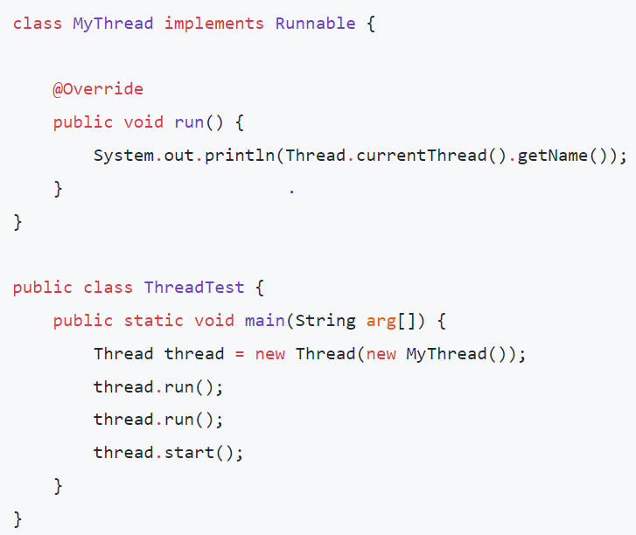

* 1. main

main

Thread – 0

* 1. Thread – 0

main

Thread – 1

* 1. Thread – 0

Thread – 1

Main

1. What is the output of this program Ans - c

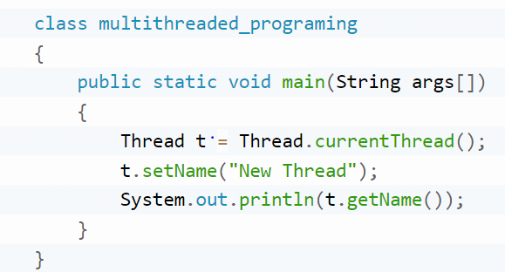

* 1. main
  2. Thread
  3. New Thread
  4. Thread[New Thread,5,main]

1. What is the output of this program Ans - d

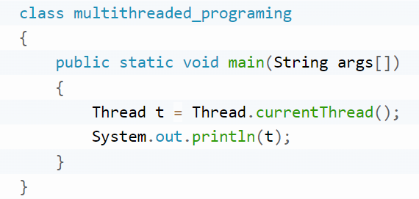

* 1. Thread[5,main]
  2. Thread[main,5]
  3. Thread[main,0]
  4. Thread[main,5,main]

1. What is the output of this program Ans - b  
   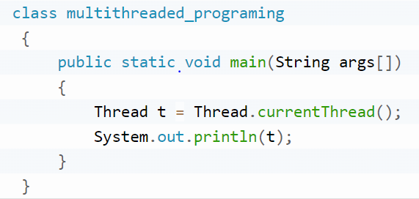
   1. 4
   2. 5
   3. 0
   4. 1
2. What is the output of this program Ans - d

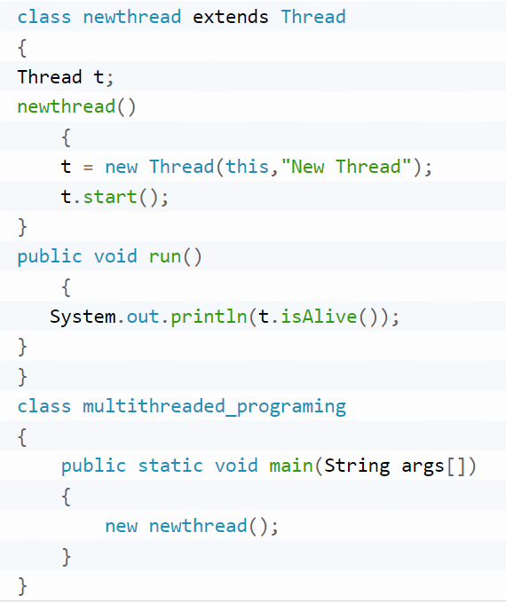

* 1. 0
  2. 1
  3. False
  4. True

1. What is the output of this program Ans - c

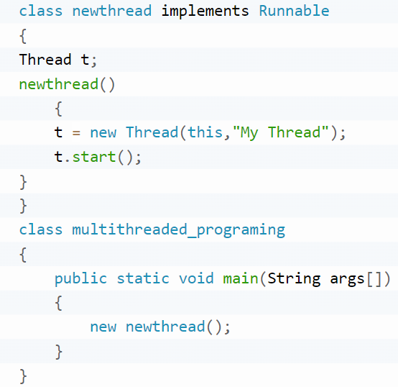

* 1. My Thread
  2. Thread[My Thread,5,main]
  3. Compilation Error
  4. Runtime Error